KIPET Documentation
(Kinetic Parameter Estimation Toolkit)

KIPET is an open-source Python package developed through a partnership between Eli Lilly and Company and Carnegie Mellon University. The package is primarily used for the estimation of kinetic parameters from spectral/concentration data. It can also be used to simulate reactive systems, estimate data variances, and obtain confidence intervals of the kinetic parameters obtained. This is all possible through a unified framework based on maximum likelihood principles, robust discretization methods, and large-scale nonlinear optimization.
In this document the capabilities of KIPET are described and examples and tutorials are given so that a user with basic programming knowledge can use the toolkit for their own purposes.


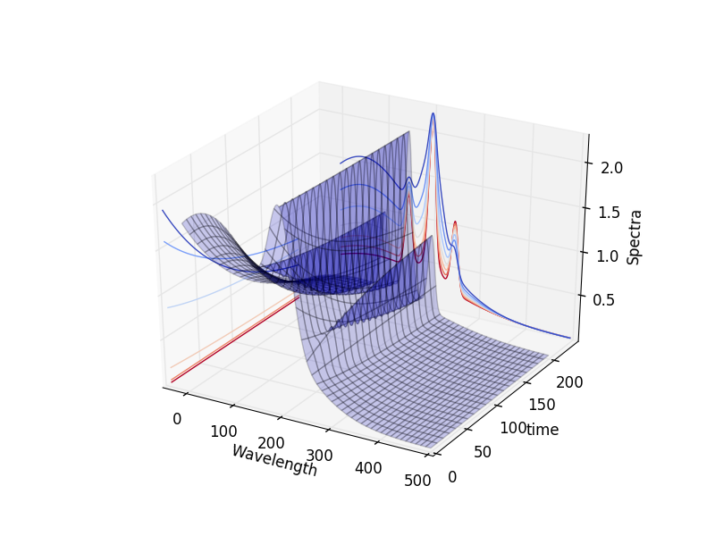

For any questions regarding Kipet please contact Prof Larry Biegler: lb01@andrew.cmu.edu
For technical details or to help with the development of the software please join the Github page:
XXXXXXXXXXXX.
Kipet is developed by Salvador Garcia-Munoz (Eli Lilly), Santiago Rodriguez (Purdue University), Lorenz T. Biegler, David M. Thierry, Christina Schenk, and Michael Short (Carnegie Mellon University)
Based on the paper: Chen, W., Biegler, L.T., Garcia-Munoz, S., 2016, An Approach for Simultaneous Estimation of Reaction Kinetics and Curve Resolution from Process and Spectral Data, Journal of Chemometrics, 30, 506-522.

LICENSE DETAILS?
=================================
Welcome to Kipet’s User Guide!
=================================
Contents:
1. OVERVIEW/INTRODUCTION

2. INSTALLATION GUIDE

2.1 Python Installation
2.1.1 Microsoft Windows installation
2.1.2 MacOS installation
2.1.3 Linux installation
2.2 Installing Packages and dependencies
2.2.1 Installer
2.2.2 Installing required dependencies
2.3 Installing Kipet
2.4 Installing solver/IPOPT and sIpopt
2.5 Windows PATH Management

3. BACKGROUND

3.1 General modeling strategy and method
3.2 Setting up and understanding a model in Kipet

4. TUTORIALS

4.1 General Model Details
4.2 Tutorial 1 – Simulating a simple reactive system
4.2.1 TemplateBuilder
4.2.2 PyomoSimulator
4.2.3 Visualizing and viewing results
4.3 Tutorial 2 – Parameter Estimation
4.3.1 Reading data
4.3.2 TemplateBuilder
4.3.3 VarianceEstimator
4.3.4 ParameterEstimator
4.3.5 Confidence intervals
4.3.6 Visualizing and viewing results
4.4 Tutorial 3 – Advanced reaction systems with additional states
4.5 Tutorial 4 – Simulation of Advanced Reaction system with Algebraic equations
4.6 Tutorial 5 – Advanced reaction systems with additional states using finite element by finite element approach
4.7 Tutorial 6 – Reaction systems with known non-absorbing species in advance

5. ADDITIONAL FUNCTIONALITIES

5.1 Data manipulation tools
5.1.1 Input matrices
5.1.2 Generating input matrices
5.1.3 Writing matrices to files
5.1.4 Plot spectral data
5.2 Pyomo Simulator
5.3 Optimizer Class
5.4 VarianceEstimator
5.5 ParameterEstimator
5.6 Troubleshooting and advanced strategies for difficult problems

6. REFERENCES

1. OVERVIEW / INTRODUCTION

The Kinetic Parameter Estimation Toolkit (Kipet) is mainly used for solving dynamic parameter estimation problems that come from chemical reaction systems. The package solves an iterative optimization-based procedure in order to estimate the variances of the noise in system variables (such as concentrations) and spectral measurements. Having estimated the system variances, one can use Kipet to estimate kinetic parameters of chemical reaction models and provide confidence intervals on the estimated parameters. The idea is to provide flexible tools that will allow users to estimate not only kinetic parameters but also the corresponding concentration and absorption profiles (Figures 2) from multi-wavelength spectroscopic data. (Figure 1)

Figure 1: Visualization of multi-wavelength spectroscopic data
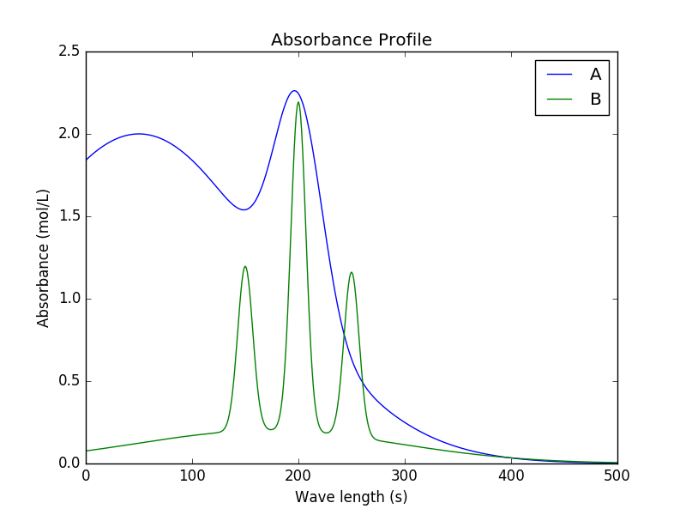
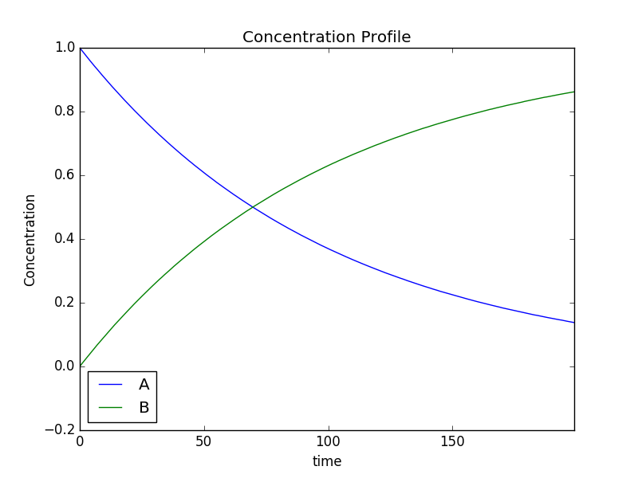

Figure 2: Absorbance profiles for single components (left) and concentration time profiles (right)

Additionally Kipet can also be used to obtain a better understanding of a chemical reaction system through inclusion of functionalities that allow for the simulation and optimization of reactive systems that are described by differential algebraic equations (DAEs). The following functionalities are included within the Kipet package:

* Simulation of a reactive system described with DAEs
* Solve DAE systems with collocation methods
* Estimate data variances
* Estimate kinetic parameters
* Estimate confidence intervals of the estimated parameters
* Visualize results

In the sections that follow this document provides guidelines on how to make use of Kipet. A detailed installation guide is provided, including a list of all packages required to use Kipet.. A guide for using some of the various capabilities is then provided in the form of tutorial examples. Finally the documentation provides references and further reading that provides more detail on the theory behind the numerical techniques implemented in Kipet.

2. INSTALLATION GUIDE

This section will explain how to install Kipet on different operating systems. Firstly Python will need to be installed.
2.1 Python installation
It should be noted that this guide is intended for beginner users and those that already have Python and an IDE installed can move onto the next section that describes the required packages their versions and the Kipet installation instructions.
Check to see whether Python is already installed by going into the command line window and typing “python”. Do this by searching “terminal” in Linux and MacOS, and “cmd” in Windows. If there is a response from a Python interpreter it should include a version number. Kipet should work with any version of Python from 2.7 up until 3.6.5. If you use Python 3.6.5 the corresponding tkinter module python3.6-tk needs to be installed as well.
Information on downloading and installing Python for windows is found here. If the user is new to Python and/or uncomfortable with command line interfacing, it is recommended that the user use Anaconda as the Integrated Development Environment (IDE). Anaconda can be downloaded for free and can be installed to include Python, associated packages, as well as a code editor.
Firstly go to the Anaconda download page and select the appropriate option for your operating system and computer architecture.

2.1.1 Microsoft Windows installation
For Windows, double-click the .exe downloaded from the site and follow the instructions. During installation the user will be asked to “Add Anaconda to my PATH environment variable” and “Register Anaconda as my default Python X.X”. It is recommended to include both of these options.
After installation, launch Anaconda Navigator by searching for it in your start menu or by launching Anaconda Prompt and typing “anaconda-navigator”.

2.1.2 MacOS
For MacOs double-click on the downloaded .pkg installer and follow the prompts. During installation the user will be asked to “Add Anaconda to my PATH environment variable” and “Register Anaconda as my default Python X.X”. It is recommended to include both of these options.
Open Launchpad and click on the Terminal icon. In the Terminal window type “anaconda-navigator”.

2.1.3 Linux installation
Enter the following into the terminal to install Anaconda:
bash ~/Downloads/Anaconda3-5.1.0-Linux-x86_64.sh
Follow the instructions and be sure to enter Yes when the installer prompts “Do you wish the installer to prepend the Anaconda 3 install to PATH in your /home/<user>/.bashrc ?”.
Close the terminal in order for the installation to take effect.
To verify the installation, open the terminal and type “anaconda-navigator”. The Anaconda Navigator should open, meaning that you have successfully installed Anaconda.

2.2 Installing Packages and Dependencies
In order to ensure that the dependencies are installed correctly an installer should be used.

2.2.1 Installer
It is recommended to use pip to install all packages and dependencies. If the user already has Python 2.7.9 and up or Python 3.4 and up installed, pip is already included and can be updated using (from the command line or terminal):
python -m pip install -U pip

This command needs to be performed from the directory where Python is installed. E.g. If you have Anaconda installed you can open navigate to the directory where it is installed and then enter the appropriate commands.
Alternatively you can enter the following in Anaconda Prompt:
pip install -U pip

For Linux or MacOS. If the user is making use of Anaconda it can be updated using:
conda update anaconda

Note that pip is included in Anaconda and should be up to date if the above is used. If more help is required to install pip, instructions are included here.

2.2.2 Installing Required Dependencies
Now that pip is installed and updated, we can install the other dependencies and third-party packages required for Kipet. Some of the major dependencies include:
* Numpy (van der Walt, 2011): used to support large, multi-dimensional arrays and matrices,
http://www.numpy.org/
* Scipy (van der Walt, 2011): used to support efficient routines for numerical integration,
http://www.scipy.org/
* Pandas (McKinney, 2013): used to analyze and store time series data,
http://pandas.pydata.org/
* Matplotlib [Hunter2007]_: used to produce figures,
http://matplotlib.org/
* Pyomo [Hart2012]_: used for formulating the optimization problems
http://pyomo.org/
A complete list of all the dependencies is included in Table 1.
If using Anaconda or another scientific Python distribution such as Python(x,y), most of the packages are already installed as part of the distribution. These include Numpy, Scipy, Pandas, Matplotlib, and CasADi. If using another Python distribution, then each package can be installed individually using pip by the following commands in the MacOS and Linux terminal and the cmd in Windows:
python -m pip install -U numpy

or via the Anaconda Prompt:
pip install -U numpy

Where “numpy” is just one example of the packages that will need to be installed.
In order to install packages when using Anaconda we can also use the following commands:
conda install -c conda-forge pyomo

In fact, using Anaconda, Pyomo should be the only additional package to install, as all others should be included in the original environment. It is recommened that the user installs pyomo using the above command in Anaconda prompt in order to ensure pyomo is installed in the correct folder. If any trouble is encountered during installation of any of the dependencies please go to the relevant package websites and follow the more detailed instructions found there.
There is also the possibility of installing all the required dependencies with the adequate versions using:
cd kipet
pip install -r requirements.txt

Be aware of that if you need other versions of the required packages for another python based software, you should rather install kipet in an virtual environment and run it in this virtual environment.
TABLE 1: List of dependencies required for Kipet to function
Package | Version
appdirs | 1.4.3
backports.functools-lru-cache | 1.5
casadi | 3.4.0
coverage | 4.5.1
cycler | 0.10.0
decorator | 4.2.1
kiwisolver | 1.0.1
matplotlib | 2.2.0
networkx | 2.1
nose | 1.3.7
numpy | 1.14.2
pandas | 0.22.0
ply | 3.11
Pyomo | 5.4.3
pyparsing | 2.2.0
Python-dateutil | 2.7.0
pytz | 2018.3
PyUtilib | 5.6.2
scipy | 1.0.0
six | 1.11.0
subprocess32 | 3.2.7
2.3 Installing Kipet

Firstly Kipet’s source code can be downloaded from https://github.com/dthierry/kipet or through the following command in Linux if git is installed:
git clone https://lilly/git/kipet.git kipet

Linux and MacOs

To install Kipet on Linux or MacOS we simply find the directory in the command prompt with the following command:
cd kipet

and then install using:
python setup.py install

Microsoft Windows
On Microsoft Windows we can install Kipet by finding either your command prompt or Anaconda Prompt and going into the Kipet folder using:
cd kipet

And then using:
python setup.py install

2.4 Installing solver / IPOPT (sIpopt)
Currently the only nonlinear solver implemented and tested in Kipet is IPOPT (Wächter and Biegler, 2006). This document only provides basic instructions on the easiest method to install the solvers. For a detailed installation guide please refer to the COIN-OR project website.

Linux/MacOS installation
Download the IPOPT tarball and then issue the following commands in the relevant directory:
gunzip Ipopt-x.y.z.tgz
tar xvf Ipopt-x.y.z.tar

Where the version number is x.y.z. Rename the directory that was just extracted:
mv Ipopt-x.y.z CoinIpopt

Then go into the directory we just created:
cd CoinIpopt

and we create a directory to move the compiled version of IPOPT to, e.g.:
mkdir build

and enter this directory:
cd build

Then we run the configure script:
./configure

make the code
make

and then we test to verify that the compilation was successfully completed by entering:
make test

Finally we install IPOPT:
make install

Microsoft Windows
The simplest installation for Microsoft windows is to download the pre-compiled binaries for IPOPT from COIN-OR. After downloading the file and unzipping it you can place this folder into the Pyomo solver location:
C:\Users\USERNAME\Anaconda3\Lib\site-packages\pyomo\solvers\plugins\solvers

Run an example (explained in the next section) to test if it works. This method should also include a functioning version of sIpopt and so the next step is not necessary unless another method of installation is used.
If trouble is experienced using this approach other methods can be used and they are detailed in the Introduction to IPOPT document.

sIPOPT installation
sIPOPT is necessary for performing sensitivity analyses. Kipet uses sIPOPT for the computation of the confidence intervals of the estimated parameters.
Additional information on how to install sIpopt can be found in:
https://projects.coin-or.org/Ipopt/wiki/sIpopt
It is important to notice here that the instructions for windows, if the solver was installed as shown above, will not work with sIpopt as no binaries for sIpopt are available. Because of this you will need to follow the Cygwin installation instructions provided by the IDAES group’s Akula Paul, included in the same folder as this documentation with the filename of: “Ipopt_sIpopt_Installation_on_Windows_cygwin.pdf”.

2.5 Windows PATH Management
If there are issues found with running examples it may be necessary in Windows to add Python to the PATH environmental variable. This can be done through your IDE, Spyder, in the case of this document by following these steps. Navigate to to Tools>PYTHONPATH Manager in Spyder and add the folder C:\Users\Username\Anaconda3 to the PATH.
If the user would like to use Python commands from the command prompt, as opposed to the Anaconda prompt, then Python can be added to the PATH Environmental Variable by going into the Start Menu, right-clicking on My Computer and clicking on Advanced Settings in Properties. In this window one can find “Environment Variables”. Click Edit and add Python to the PATH variable by adding the location of where Python is installed on your system.
You should now be ready to use Kipet!

3. BACKGROUND

This documentation focuses on kinetic studies for the investigation of chemical reactions and identification of associated rate constants from spectroscopic data. The methodology is the same as published in Chen, et al. (2016), where the technical details are laid out in significant detail. In this document the user will find a summary of the procedure in the paper as well as how this method has been transferred to Kipet. This document will therefore attempt to only describe as much detail as necessary in order to understand and use Kipet.

3.1 General modeling strategy and method
After installing and importing the package users can do the following things:
* Build a chemical reaction model
* Simulate the model
* Estimate variances in the data
* Estimate parameters
* Compute confidence intervals of the estimated parameters
* Plot concentration and absorbance profiles
The first thing to do in Kipet is to create a model. A model contains the physical equations that represent the chemical reaction system dynamics. Once a model is created users can either make a simulation by solving the DAE equations with a multi-step integrator or through a discretization in finite elements. Alternatively an optimization can be performed in which the DAE equations are the constraints of the optimization problem. In general, Kipet provides functionality to solve optimization problems for parameter estimation of kinetic systems. For the construction of optimization models Kipet relies on the Python-based open-source software Pyomo. Pyomo can be
used to formulate general optimization problems in Python. After a model is created users can extend the model by adding variables, equations, constraints or customized objective functions in a similar way to Pyomo. After the simulation or the optimization is solved, users can visualize the concentration and absorbance profiles of the reactive system. These steps are summarized in the following figure:
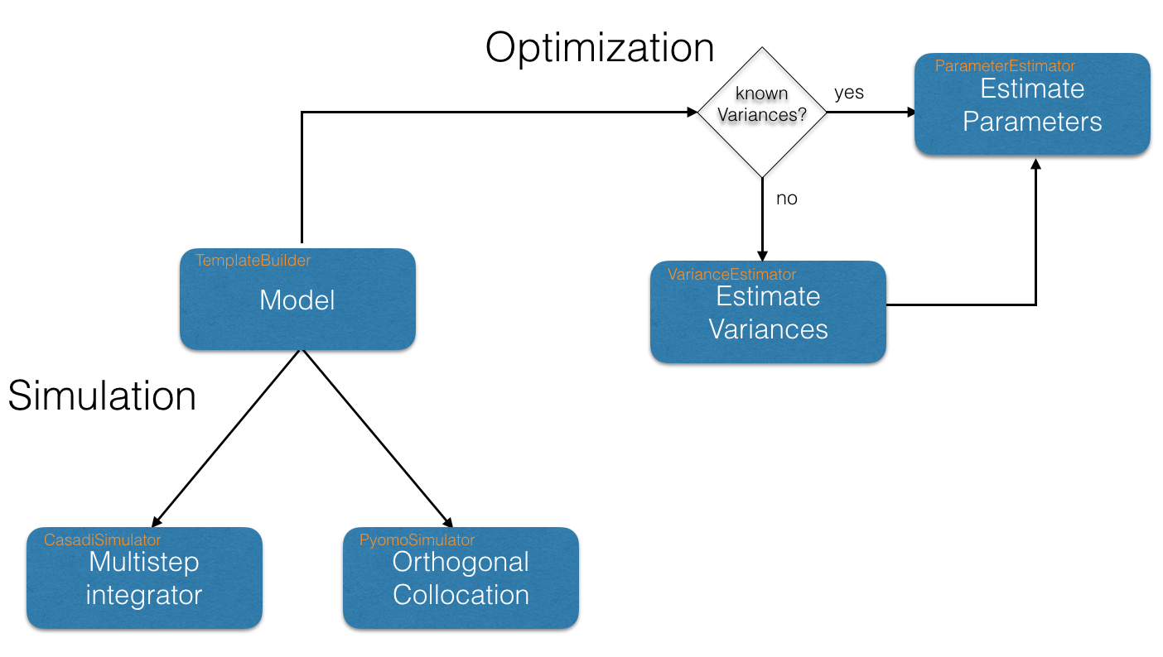
Figure 3: The steps/modules involved in setting up a Kipet model
It should be noted that in the above figure, the location of the source-code for each module is included in the orange text in the top-left section of each box. You may wish to refer back to this figure during the setting up of models to decide on which modules from within Kipet to use and call upon.
To facilitate the creation of models Kipet provides a helper class that makes the creation of kinetic models easier. The helper class TemplateBuilder transforms the user’s model into a Pyomo formulation “under the hood” automatically. In general the TemplateBuilder creates models with the following attributes:

* Noised concentration variable of each component, C
* Unnoised/actual concentration variable of each component, Z
* Pure component absorption variable, S
* Complementary state variables, X
* Complementary algebraic variables, Y
* Kinetic parameters, P
The variable nomenclature follows the same labeling structure as used in the original paper, Chen et al. (2016). Once the model is created it can be simulated or optimized. Kipet simulates and optimizes Pyomo models following a simultaneous approach. In the simultaneous approach all of the time-dependent variables are discretized to construct a large nonlinear problem. Due to the nature of large nonlinear problems, good initial guesses for variables are essential. Kipet provides a number of tools to help users to initialize their problems, including through the use of running simulations with fixed guessed parameters, using a least squares approach with fixed parameters, or through a finite element by finite element approach using Kipet’s in-built Fe_Factory (recommended for large problems).
Kipet therefore offers a number of simulator and optimizer classes that facilitate the initialization and scaling of models before these are called for simulation. In addition, the simulator and optimizer classes available in Kipet will store the results of the simulation/optimization in pandas DataFrames for easy visualization and analysis. More information on this and why this is relevant to the user will follow during the tutorial problems.
Kipet offers two classes for the optimization of reactive models. The ParameterEstimator class estimates kinetic parameters from spectral data by solving the problem formulation described in Chen, et al. (2016). Within this class the objective function is constructed with Pyomo and added to the model that is passed to the solver. If the user provides a model with an active objective function however, the ParameterEstimator will optimize the objective function provided by the user. This class also offers the ability to determine the confidence intervals of the estimated parameters. For all calculations in the ParameterEstimator class the variances of the spectral data need to be provided. When the variances are not known the user can use the VarianceEstimator optimizer class instead to determine them.
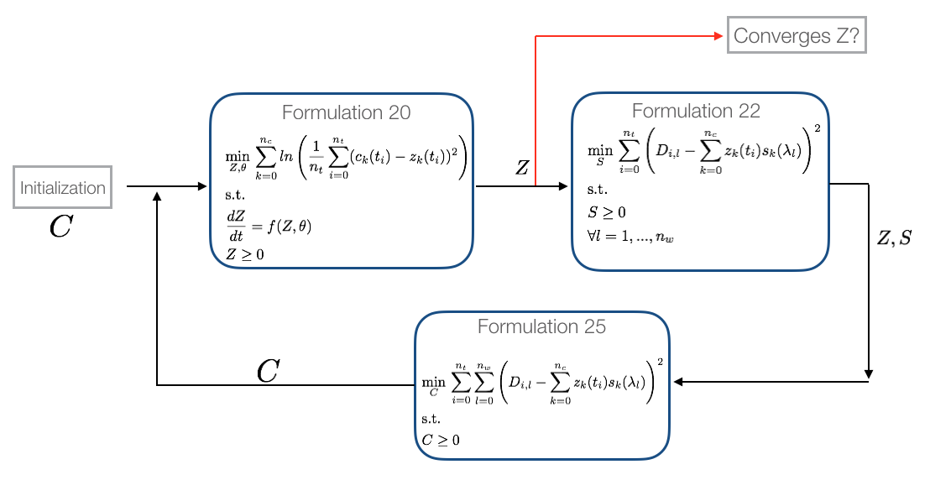
The variance estimation procedure is described in detail in Chen, et al. (2016). The procedure consists of solving three different nonlinear optimization problems in a loop until convergence on the concentration profiles is achieved. The following figure summarizes the variance estimation procedure based on maximum likelihood principles:

Figure 4: The VarianceEstimator class algorithm

The VarianceEstimator class will construct the three problems and solve them with a nonlinear solver until the convergence criteria is satisfied. By default Kipet checks for the infinite norm of the residuals of Z between two iterations. If the infinity norm is less than the tolerance (default 5e-5) then variances are estimated by solving the overdetermined system shown in Figure 5.
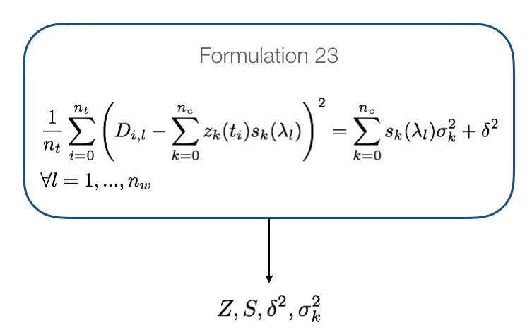

Figure 5: Variance estimation equations
The solution of each subproblem in this procedure is logged in the file iterations.log. Examples on how to use the optimization classes and their corresponding options can be found in the tutorial section of this document. It should be noted at this point that all that is required to determine the variances in this way are the components, their initial concentrations, the differential equations describing the reactions, and the spectroscopic data absorption matrix, D, which consists of the experimental absorption data with rows (i) being the time points and columns (l) being the measured wavelengths.
Once the variances are estimated we not only attain good estimates for the system noise and the measurement error, but we have also obtained excellent initializations for the parameter estimation problem, as well as good initial values for the kinetic parameters to pass onto the ParameterEstimator class.
Where Equation 17 from Chen, et al. (2016) is solved directly:
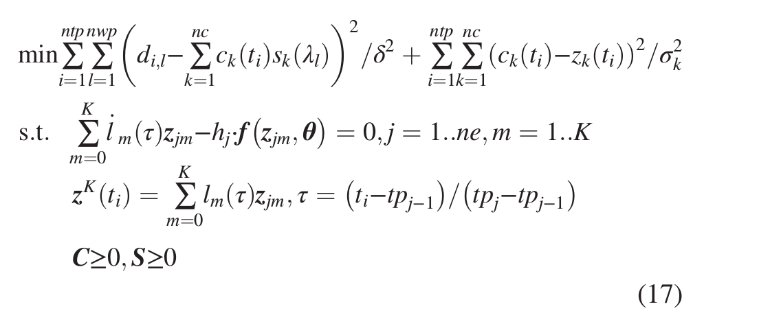

Note here that this can be solved either directly with the variances and measurement errors manually added and fixed by the user, or through the use of the VarianceEstimator.
It is also important at this point to note that we can solve the ParameterEstimator problem either using IPOPT to get the kinetic parameters or we can use sIPOPT to perform the optimization with sensitivities in order to determine the confidence intervals.
3.2 Setting up and understanding a model in Kipet
Once all of the software required for Kipet is installed, we can begin learning and testing the toolkit by opening the “Ex_1_ode_sim.py”. The template examples are some simple tutorial examples designed to assist new users in utilizing the software and are also meant to allow for easy manipulation so that the user can alter the code for their own specific uses.
Before getting started with Kipet it is useful for users to be familiar with basic Python programming. The Python website provides users with a basic tutorial.
To use Kipet, import the package from within a python console:
import kipet

If you are new to Python or a novice in coding, you can open the example by starting the IDE of your choice and loading the example from the folder where Kipet is installed. For those using the recommended Anaconda platform, launch Anaconda-Navigator (either from the start menu in Windows or by typing “anaconda-navigator” into the terminal in Linux/MacOS) and then launching the Spyder IDE from the Homepage.
In this section the user will be guided through the various types of problems that Kipet was designed to solve, with detailed line-by-line analysis of the example files, with particular attention being given to the areas of the code where it is intended for users to interact in order to implement their own problems. The tutorials section will be broken down into:
General model details
This is information that needs to be supplied by the user for every problem to be solved in Kipet.
Data handling
In this section we will look at which types of data can be handled by Kipet and what form the data files need to be supplied in.
Simulation
This section deals with the simplest type of problem that can be solved in Kipet, involving plotting concentration vs time graphs for the specified systems with the systems’ parameters specified. If the individual pure species’ absorbances (S-matrices) are known these can also be inputted to obtain the expected absorbance profiles (D-matrix) for the system.
Variance Estimation
This section will show how to use the VarianceEstimator class to estimate the measurement error and noise in the data.
Parameter Estimation
Kipet’s most valuable and powerful class is described here, allowing for the estimation of kinetic parameters. This section will explain how the user calls upon the ParameterEstimator class and how to solve the discretization and optimization problem.
Advanced problems with complementary states
This section will demonstrate the way in which more advanced systems can be solved by introducing complementary state variables and algebraic variables to introduce complexities that may also change with time such as temperature, densities, volumes, etc.

4. TUTORIALS

This section will look at specific example files provided with the Kipet software and explain, line-by-line the sections that a user will need to modify in order to solve their own problems. All lines of code that are not explained in this tutorial are necessary for the code to function, but should not need to be altered by the user. For brevity these lines are omitted.
Firstly we will look at the pieces of information that every Kipet model requires to function.
4.1 General Model Details
In order to fully understand the model-building process and results obtained, the user needs to be familiar with the nomenclature used.

Variables:
Z -- unnoised concentrations of each species, continuous in time.
C – concentration matrices with noise.
S -- pure component absorbance matrices.
X – algebraic variables such as volume, temperatures, densities, etc.
P – kinetic parameters (can be fixed for simulations)

Parameters and (indices):
Components, (k) – the components, with index k
Meas_times, (t) – the measurement times from the data file.
Meas_lambdas, (l) – the wavelengths from the experimental data.

Every Kipet model requires a number of things in order to function. This includes a list of the components in the system, identification of the components that will be absorbing, a list of the reactions (noting that each component requires an ODE), and a number of class and function calls that will be detailed in the sections to follow.
Generally the code can be broken down into a number of steps, with some of the steps only being applicable to certain model applications. Each of these steps will be described in the sections to follow within this document, with examples as to how to use the relevant functions for your own problems. These steps are summarized as:
1. Reading data
Only required for problems where absorbance data is available.
2. TemplateBuilder
This section is required for all models and is where the components, ODEs, and other problem-specific data is inputted.
3. Simulator
This section is required if a simulation is being performed and can call either upon PyomoSimulator. Noise can also be simulated and added to the results or used to generate a D-matrix. The simulators can also be used to initialize the parameter estimation problem if needed.
4. VarianceEstimator
This is meant for problems where we have a D-matrix from experimental data with measurement error and random noise. Can also be used to initialize the kinetic parameter estimation.
5. ParameterEstimator
Used to simultaneously determine the concentration-time profiles and kinetic parameters using orthogonal collocation on finite elements, as described previously in this document. Can also determine the covariances and confidence intervals associated with the kinetic parameters.
6. Visualising and viewing results
Finally we can visualize the results by using the matlplotlib graphing functions as well as printing the variances, kinetic parameters, and confidence intervals.
The next sections will provide some tutorials as to allow the user to use all of Kipet’s functionality.

4.2 Tutorial 1 – Simulating a Simple Example

If you do not know how to get started, open Anaconda Navigator and then run Spyder IDE. In Spyder open the example by navigating into Kipet’s example folder and opening the relevant example. Run the example by pressing the green play button. We will start by going through the example “Ex_1_ode_sim.py”. This example provides a basic 3-component, 2 reaction system with A → B and B → C, where the kinetic rate constants are fixed.

4.2.1 TemplateBuilder
The first line of interest to the user will be the line:
builder = TemplateBuilder()

Where we use the required TemplateBuilder class to begin creating our model. This class is required for every Kipet example and allows the user to construct the Pyomo model in the background. While the user does not need to interact with this line, it is useful to realise its importance. The lines that follow allow us to define the components that we expect to be present in the mixture.
builder.add_mixture_component('A',1)
builder.add_mixture_component('B',0)
builder.add_mixture_component('C',0)

Where the first function input is the name of the component and the second input is the initial concentration in the mixture. Following this is the next required user input, the definition of the kinetic parameters:
builder.add_parameter('k1',2.0)
builder.add_parameter('k2',0.2)

Where the first function input is the name of the kinetic parameter and the second input is the value. For this first example we are fixing the values of the kinetic parameters in order to simulate the system. If we wish to optimize the system we can either leave this second argument out or add bounds, like in the following example:
builder.add_parameter('k1', bounds=(0.0, 5.0))
builder.add_parameter('k2', bounds=(0.0, 1.0))

Following the definition of our basic reaction system, every Kipet model requires a set of ODEs to be defined. Please note that Kipet requires that every component that is identified in the mixture has an expression. The ODEs are inputted in the following way for this example:

def rule_odes(m,t):
exprs = dict()
exprs['A'] = -m.P['k1']*m.Z[t,'A']
exprs['B'] = m.P['k1']*m.Z[t,'A']-m.P['k2']*m.Z[t,'B']
exprs['C'] = m.P['k2']*m.Z[t,'B']
return exprs

After defining the equations in this way we can add them to our template which will create the Pyomo model using:
builder.set_odes_rule(rule_odes)

So now that the model is defined we can decide what to do with it. In this example the goal is to simulate the known reaction system and obtain concentration vs time profiles.
4.2.2 PyomoSimulator
We will do this by sending our “builder” model through the PyomoSimulator class, which discretizes the system and solves an optimization problem using orthogonal collocation on finite elements. Firstly, we define our pyomo model using our builder TemplateBuilder:
pyomo_model = builder.create_pyomo_model(0.0,10.0)

Where the two arguments are the time period that we would like to simulate over. We then pass this new model onto the PyomoSimulator class:
simulator = PyomoSimulator(pyomo_model)

and apply the discretization that we would like for the ODEs:
simulator.apply_discretization('dae.collocation',nfe=30,ncp=2,scheme='LAGRANGE -RADAU')

The arguments that need to be supplied use the same keywords as the pyomo.dae method. And need to include all the arguments above. Where “nfe” is the number of finite elements, the higher the number the more accurate your solution is likely to be but at the cost of higher computational costs. “ncp” is the number of collocation points within each finite element. As this number increases, the computational costs increase dramatically and the chances of a converged/feasible solution decrease. The “scheme” refers to the type of collocation to be applied, with two options available to users, either collocation using Lagrange-Radau (as above) roots or using Lagrange-Legendre (scheme=’LAGRANGE-LEGENDRE’). It is highly recommended that the user use Lagrange-Radau (which is also the default option if the argument is omitted) as this has been shown to produce more numerical stability for complex problems, such as the ones usually encountered in Kipet.
Finally we are ready to run the simulation in Pyomo with the following line:
results_pyomo = simulator.run_sim('ipopt',tee=True)

where ‘ipopt’ is the IPOPT nonlinear program (NLP) optimization solver and the option “tee” is to stream the solver output to the console. For more information on additional arguments, please refer to the function guide in section 5.2.
4.2.3 Visualizing and viewing results
Finally, to view the results of the optimization-based simulation we use the matlplotlib function
if with_plots:
results_pyomo.Z.plot.line(legend=True)
plt.xlabel("time (s)")
plt.ylabel("Concentration (mol/L)")
plt.title("Concentration Profile")
plt.show()

Where we are plotting the concentration vs time graph with the unnoised concentration, Z. The plot obtained from this example is shown in Figure 6.
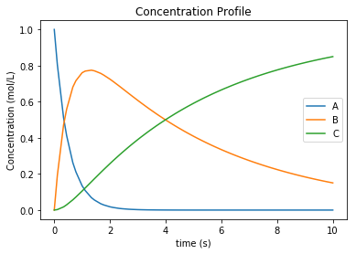

Figure 6: Plot obtained from tutorial example 1

4.3 Tutorial 2 – Parameter Estimation

In the second example we will be looking at a parameter estimation problem where we combine most of the elements discussed in the Overview section of this document. This model is label “Ex_2_estimation.py”. This example is the same reaction system as tutorial 1, except in this case we use a simulated data set as our input D-matrix. This example, while not too computationally complex provides a good overview of all the capabilities of Kipet.

4.3.1. Reading data

Firstly we will need to input our D-matrix, which contains the spectral data. More notes on the structure of these data files and which file types are permitted are included in the section on data files. In order to do this we need to point the model to the data file. We can do this by using the following lines:

dataDirectory = os.path.abspath(os.path.join( os.path.dirname( os.path.abspath(inspect.getfile(
inspect.currentframe() ) ) ), '..','data_sets'))
filename = os.path.join(dataDirectory,'Dij.txt')
D_frame = read_spectral_data_from_txt(filename)

where dataDirectory points to the folder/directory where the data file is found. The ‘..’ refers to changing directory back one and ‘data_sets’ is the name of the folder where the data file is found. The filename refers to the exact location of the data file, ‘Dij.txt’. Finally we define the D_frame which uses the Kipet function read_spectral_data_from_text().
4.3.2. TemplateBuilder
The TemplateBuilder is constructed in the same way as in the previous example, except in this case we add the parameters with bounds as opposed to fixed values. This is done in the following way:
builder.add_spectral_data(D_frame)

The components, ODEs, and the optimization problem are all set up in the same way as was previously explained.

4.3.3. VarianceEstimator
After the Pyomo model is set up with the TemplateBuilder the VarianceEstimator is called, followed by the discretization scheme, as was previously shown:
v_estimator = VarianceEstimator(opt_model)
v_estimator.apply_discretization('dae.collocation',nfe=60,ncp=1,
scheme='LAGRANGE-RADAU')

The next section of code run the optimization procedure described in the Overview section and detailed in Chen, et al. (2016).
options = {}
A_set = [l for i,l in enumerate(opt_model.meas_lambdas) if (i % 4 == 0)]
results_variances = v_estimator.run_opt('ipopt', tee=True, solver_options=options,
tolerance=1e-5,max_iter=15, subset_lambdas=A_set)

Where the solver is ’ipopt’, tee = True is to stream the optimizer output to the console, solver options are related to the IPOPT solver and can be viewed in the IPOPT manual. In the case of this example, no options are given to the solver and allowing Kipet to provide good default options. The tolerance argument is the tolerance required for the termination of the variance estimator for the change in Z between iterations, as described in the paper. The max_iter argument is for the maximum number of iterations of the iterative procedure described in Figure 4.
subset_lambdas = A_set is the set of wavelengths to use in initializing the problem, default=all. For large problems it might be worth making that smaller as it allows the VarianceEstimator a smaller set to work with. For problems with a lot of noise, this can be very useful and was shown in the paper to be equally effective as including the entire set of wavelengths. A_set in this example is set to be every fourth value.
After the VarianceEstimator iterative procedure is completed, the results can then be printed:
print "\nThe estimated variances are:\n"
for k,v in results_variances.sigma_sq.items():
print k,v
sigmas = results_variances.sigma_sq

This should output the following for this example:
The estimated variances are:

A 4.5576011654506495e-12
device 1.8751166756864294e-06
C 2.412124777715806e-11
B 3.33664956457665e-11

Where the “device” refers to the measurement error.

4.3.4. ParameterEstimator
After rewriting the Pyomo model created from the VarianceEstimator, the ParameterEstimator function is created:
p_estimator = ParameterEstimator(opt_model)

Discretization is then applied to the p_estimator, as in the previous example, and before running the ParameterEstimator optimization we can use the VarianceEstimator’s results in order to initialize the p_estimator model. This is only possible if the VarianceEstimator is used, but it can also be omitted. Note that the discretization of the p_estimator has to be done with the same element and collocation point placement in order to maximize the benefits of the initialization step.
p_estimator.initialize_from_trajectory('Z',results_variances.Z)
p_estimator.initialize_from_trajectory('S',results_variances.S)
p_estimator.initialize_from_trajectory('C',results_variances.C)

IPOPT performs rudimentary scaling of variables automatically. Some problems may, however, require more detailed scaling information so that IPOPT can perform in an efficient manner. In order to use the scaling information from the previous optimization we may use the following:
p_estimator.scale_variables_from_trajectory('Z',results_variances.Z)
p_estimator.scale_variables_from_trajectory('S',results_variances.S)
p_estimator.scale_variables_from_trajectory('C',results_variances.C)

Once again, this step is not a necessity for all problems, particularly those that are well-scaled for IPOPT. If this variable scaling is included then the optimization step will need to include the NLP scaling option, as demonstrated below:
options = dict()
options['nlp_scaling_method'] = 'user-scaling
results_pyomo = p_estimator.run_opt('ipopt', tee=True, solver_opts = options, variances=sigmas)

Where the additional argument, variances = sigmas, refers to the fact that we are including the variances calculated by the VarianceEstimator.

4.3.5. Confidence intervals
If the user would like to assess the level of confidence in the estimated parameters the run_opt function needs to be changed. And example of this is found in the Example labeled “Ex_2_estimation_conf.py” in the Examples folder. Firstly the ‘ipopt_sens’ solver needs to be called. Additionally, the option for the covariance needs to be changed from the default. More information on the ParameterEstimator function is found in section 5.
options = dict()
options['mu-init'] = 1e-4
results_pyomo = p_estimator.run_opt('ipopt_sens', tee=True, solver_opts = options, variances = sigmas, covariance= True)

Please note that if this fails to run, it is likely that sIPOPT is not correctly installed, or it has not been added to your environmental variable. For help with sIPOPT, please refer to section 2.4.

For many of the problems it is not possible to use the user scaling option as the solver type has now changed. In addition, since the stochastic solver requires the solving of a more difficult problem, it is sometimes necessary to apply different solver options in order to find a feasible solution. Among the options commonly found to increase the chances of a feasible solution, the ‘mu-init’, option can be set to a suitably small, positive value. This option changes the initial variable value of the barrier variable. More information can be found on the IPOPT options website in COIN-OR.

4.3.6. Visualizing and Viewing Results
Once the optimization is successfully completed we can print the results:
print "The estimated parameters are:"
for k,v in results_pyomo.P.items():
print k,v

The results will then be shown as:
EXIT: Optimal Solution Found.
The estimated parameters are:
k2 0.201735984306
k1 2.03870135529

Which will be the estimates for parameters k1 and k2. Finally we use the same methods to display results as in the first example, but now also displaying the plots for the S (pure component absorbance) matrices:

results_pyomo.C.plot.line(legend=True)
plt.xlabel("time (s)")
plt.ylabel("Concentration (mol/L)")
plt.title("Concentration Profile")

results_pyomo.S.plot.line(legend=True)
plt.xlabel("Wavelength (cm)")
plt.ylabel("Absorbance (L/(mol cm))")
plt.title("Absorbance Profile")

Providing us with the following plots:
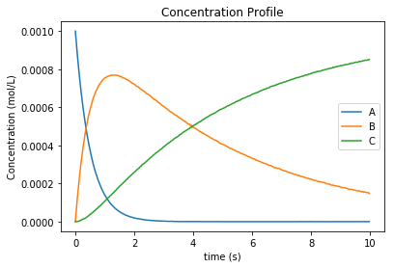

Figure 7: Concentration profile results from tutorial example 2
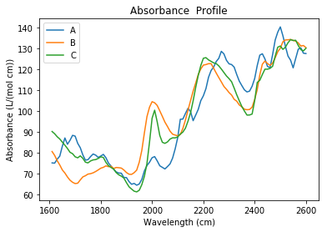

Figure 8: Pure component absorbance profiles (S) result from tutorial example 2

4.4 Tutorial 3 – Advanced reaction systems with additional states
It is also possible to combine additional complementary states, equations and variables into a Kipet model. In the example labeled “Ex_3_complementary.py” an example is solved that includes a temperature and volume change. In this example the model is defined in the same way as was shown before, however this time complementary state variable temperature is added using the following Kipet function:
builder.add_complementary_state_variable('T',290.0)
builder.add_complementary_state_variable('V',100.0)

This function now adds additional variables to the model, labeled “X”. This same formulation can be used to add any sort of additional complementary state information to the model. Now, similarly to with the components, each complementary state will require an ODE to accompany it. In the case of this tutorial example the following ODEs are defined:
def rule_odes(m,t):
k1 = 1.25*exp((9500/1.987)*(1/320.0-1/m.X[t,'T']))
k2 = 0.08*exp((7000/1.987)*(1/290.0-1/m.X[t,'T']))
ra = -k1*m.Z[t,'A']
rb = 0.5*k1*m.Z[t,'A']-k2*m.Z[t,'B']
rc = 3*k2*m.Z[t,'B']
cao = 4.0
vo = 240
T1 = 35000*(298-m.X[t,'T'])
T2 = 4*240*30.0*(m.X[t,'T']-305.0)
T3 = m.X[t,'V']*(6500.0*k1*m.Z[t,'A']-8000.0*k2*m.Z[t,'B'])
Den = (30*m.Z[t,'A']+60*m.Z[t,'B']+20*m.Z[t,'C'])*m.X[t,'V']+3500.0
exprs = dict()
exprs['A'] = ra+(cao-m.Z[t,'A'])/m.X[t,'V']
exprs['B'] = rb-m.Z[t,'B']*vo/m.X[t,'V']
exprs['C'] = rc-m.Z[t,'C']*vo/m.X[t,'V']
exprs['T'] = (T1+T2+T3)/Den
exprs['V'] = vo
return exprs

Where “m.X[t,'V']” and “m.X[t,'T']” are the additional state variables and “m.Z[t,component]” is the concentration of the component at time t. We can then simulate the model (or use experimental data if available and estimate the parameters) in the same way as described in the previous examples. Please follow the rest of the code and run the examples to obtain the output.
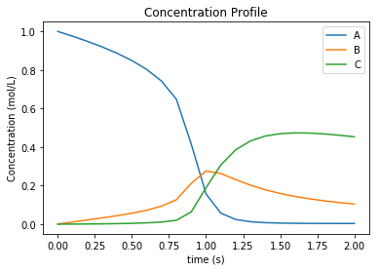

Figure 9: Output of Tutorial example 3
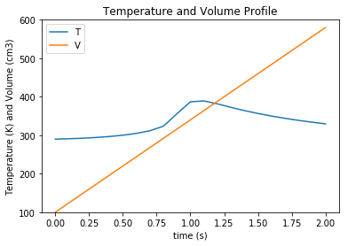

Figure 10: Output of Tutorial example 3

4.5 Tutorial 4 – Simulation of Advanced Reaction system with Algebraic equations
Now that complementary states are understood we can explain perhaps the most conceptually difficult part in Kipet, the idea of algebraic variables. The terms algebraics and algebraic variables are used in Kipet when referring to equations and variables in larger models that can be used to determine the ODEs where we have a number of states and equations. This can be illustrated with the Aspirin case study from Chen et al. (2016) where we have the more complex reaction mechanism:

With the rate laws being:

And these can then be used to describe the concentrations of the liquid and solid components with the ODEs:

This example can be described by the equations 35 (which are the “algebraics” in Kipet) and the ODEs, equations 36. which will then be the ODEs defining the system, making use of the reaction rate laws from the algebraics.
Translating these equations into code for Kipet we get the file found in Ex_4_sim_aspirin. In this example we need to declare new sets of states in addition to our components and parameters, as with Tutorial 3:
extra_states = dict()
extra_states['V'] = 0.0202
extra_states['Masa'] = 0.0
extra_states['Msa'] = 9.537
builder.add_complementary_state_variable(extra_states)

with the initial values given. In addition we can declare our algebraic variables (the rate variables and other algebraics):
algebraics = ['f','r0','r1','r2','r3','r4','r5','v_sum','Csat']

builder.add_algebraic_variable(algebraics)

Where f represents the addition of liquid to the reactor during the batch reaction.
For the final equation in the model (Equn 36) we also need to define the stoichiometric coefficients, gammas, and the epsilon for how the added water affects the changes in volume.
gammas = dict()
gammas['SA']= [-1, 0, 0, 0, 1, 0]
gammas['AA']= [-1,-1, 0,-1, 0, 0]
gammas['ASA']= [ 1,-1, 1, 0, 0,-1]
gammas['HA']= [ 1, 1, 1, 2, 0, 0]
gammas['ASAA']= [ 0, 1,-1, 0, 0, 0]
gammas['H2O']= [ 0, 0,-1,-1, 0, 0]

epsilon = dict()
epsilon['SA']= 0.0
epsilon['AA']= 0.0
epsilon['ASA']= 0.0
epsilon['HA']= 0.0
epsilon['ASAA']= 0.0
epsilon['H2O']= 1.0

partial_vol = dict()
partial_vol['SA']=0.0952552311614
partial_vol['AA']=0.101672206869
partial_vol['ASA']=0.132335206093
partial_vol['HA']=0.060320218688
partial_vol['ASAA']=0.186550717015
partial_vol['H2O']=0.0883603912169

To define the algebraic equations in Equn (35) we then use:
def rule_algebraics(m,t):
r = list()
r.append(m.Y[t,'r0']-m.P['k0']*m.Z[t,'SA']*m.Z[t,'AA'])
r.append(m.Y[t,'r1']-m.P['k1']*m.Z[t,'ASA']*m.Z[t,'AA'])
r.append(m.Y[t,'r2']-m.P['k2']*m.Z[t,'ASAA']*m.Z[t,'H2O'])
r.append(m.Y[t,'r3']-m.P['k3']*m.Z[t,'AA']*m.Z[t,'H2O'])

# dissolution rate
step = 1.0/(1.0+exp(-m.X[t,'Msa']/1e-4))
rd = m.P['kd']*(m.P['Csa']-m.Z[t,'SA']+1e-6)**1.90*step
r.append(m.Y[t,'r4']-rd)
#r.append(m.Y[t,'r4'])

# crystalization rate
diff = m.Z[t,'ASA'] - m.Y[t,'Csat']
rc = 0.3950206559*m.P['kc']*(diff+((diff)**2+1e-6)**0.5)**1.34
r.append(m.Y[t,'r5']-rc)

Cin = 39.1
v_sum = 0.0
V = m.X[t,'V']
f = m.Y[t,'f']
for c in m.mixture_components:
v_sum += partial_vol[c]*(sum(gammas[c][j]*m.Y[t,'r{}'.format(j)] for j in range(6))+ epsilon[c]*f/V*Cin)
r.append(m.Y[t,'v_sum']-v_sum)

return r

builder.set_algebraics_rule(rule_algebraics)

Where the algebraics are given the variable name m.Y[t,’r1’]. We can then use these algebraic equations to define our system of ODEs:
def rule_odes(m,t):
exprs = dict()

V = m.X[t,'V']
f = m.Y[t,'f']
Cin = 41.4
# volume balance
vol_sum = 0.0
for c in m.mixture_components:
vol_sum += partial_vol[c]*(sum(gammas[c][j]*m.Y[t,'r{}'.format(j)] for j in range(6))+ epsilon[c]*f/V*Cin)
exprs['V'] = V*m.Y[t,'v_sum']

# mass balances
for c in m.mixture_components:
exprs[c] = sum(gammas[c][j]*m.Y[t,'r{}'.format(j)] for j in range(6))+ epsilon[c]*f/V*Cin - m.Y[t,'v_sum']*m.Z[t,c]

exprs['Masa'] = 180.157*V*m.Y[t,'r5']
exprs['Msa'] = -138.121*V*m.Y[t,'r4']
return exprs

builder.set_odes_rule(rule_odes)

model = builder.create_pyomo_model(0.0,210.5257)

The rest can then be defined in the same way as other simulation problems. Note that in this problem the method for providing initializations from an external file is also shown with the lines:
dataDirectory = os.path.abspath(os.path.dirname( os.path.abspath( inspect.getfile(
inspect.currentframe() ) ) ))
filename_initZ = os.path.join(dataDirectory, 'init_Z.csv')#Use absolute paths
initialization = pd.read_csv(filename_initZ,index_col=0)
sim.initialize_from_trajectory('Z',initialization)
filename_initX = os.path.join(dataDirectory, 'init_X.csv')#Use absolute paths
initialization = pd.read_csv(filename_initX,index_col=0)
sim.initialize_from_trajectory('X',initialization)
filename_initY = os.path.join(dataDirectory, 'init_Y.csv')#Use absolute paths
initialization = pd.read_csv(filename_initY,index_col=0)
sim.initialize_from_trajectory('Y',initialization)

where the external files are the csv’s and the option index_col is from pandas and refers to the column to use for the labels. Following this, external files are also used for the flow of water fed into the reactor, as well as the saturation concentrations of SA and ASA (functions of temperature, calculated externally).
dataDirectory = os.path.abspath(
os.path.join( os.path.dirname( os.path.abspath( inspect.getfile(
inspect.currentframe() ) ) ), 'data_sets'))
traj = os.path.join(dataDirectory,'extra_states.txt')

dataDirectory = os.path.abspath(
os.path.join( os.path.dirname( os.path.abspath( inspect.getfile(
inspect.currentframe() ) ) ), 'data_sets'))
conc = os.path.join(dataDirectory,'concentrations.txt')

fixed_traj = read_absorption_data_from_txt(traj)
C = read_absorption_data_from_txt(conc)

sim.fix_from_trajectory('Y','Csat',fixed_traj)
sim.fix_from_trajectory('Y','f',fixed_traj)

4.6 Tutorial 5 – Advanced reaction systems with additional states using finite element by finite element approach
Another functionality within Kipet is to use a finite element by element approach to initialize a problem. If you consider a fed-batch process, certain substances are added during the process in a specific manner dependent on time. This can be modeled using additional algebraic and state variables, similar to the process shown in Tutorial 4. In this tutorial, the following reaction system is simulated.

Which is represented by the following ODE system:

The file for this tutorial is Ex_5_sim_fe_by_fe.py For using the finite element by finite element approach you have to import the following package
from kipet.utils.fe_factory import *

In case of having 5 rate laws, you have 5 algebraic variables but you add an extra algebraic variable which basically works as an input, such that you have 6 in total.
# add algebraics
algebraics = [0, 1, 2, 3, 4, 5] # the indices of the rate rxns
builder.add_algebraic_variable(algebraics)

Then you add additional state variables, here one additional state variable which models the volume.
# add additional state variables
extra_states = dict()
extra_states['V'] = 0.0629418

This is then included in the system of ordinary differential equations.

def rule_odes(m, t):
exprs = dict()
eta = 1e-2
step = 0.5 * ((m.Y[t, 5] + 1) / ((m.Y[t, 5] + 1) ** 2 + eta ** 2) ** 0.5 + (210.0 - m.Y[t,5]) / ((210.0 - m.Y[t, 5]) ** 2 + eta ** 2) ** 0.5)
exprs['V'] = 7.27609e-05 * step
V = m.X[t, 'V']
# mass balances
for c in m.mixture_components:
exprs[c] = sum(gammas[c][j] * m.Y[t, j] for j in m.algebraics if j != 5) - exprs['V'] / V * m.Z[t, c]
if c == 'C':
exprs[c] += 0.02247311828 / (m.X[t, 'V'] * 210) * step
return exprs

Please be aware the step equation and its application to the algebraic variable and equation m.Y[t,5] will act as a switch for the equations that require an action at a specific time. Before setting up the finite element by element initialization scheme we need to clone our model as the initialization requires to instances of the model. This is done by the following lines:
sim = PyomoSimulator(model)
mod = sim.model.clone()

Following the declaration of our system of equations we add additional initial conditions for the extra variables for fe_factory as well as for the parameters. These are shown in the code included in Kipet and take the form:
ics_['X', 'V'] = 0.0629418

It is then necessary to declare the inputs_sub which shows which variable acts as the input. And also to fix the values of the input variables time measurement points for the simulation.
inputs_sub = {}
inputs_sub['Y'] = [5]

for key in sim.model.time.value:
sim.model.Y[key, 5].set_value(key)
sim.model.Y[key, 5].fix()

which are then given to the function fe_initialize

init = fe_initialize(sim.model, mod,
init_con="init_conditions_c",
param_name=param_name,
param_values=param_dict,
inputs_sub=inputs_sub)

init.load_initial_conditions(init_cond=ics_)

init.run()

Following which a normal simulation can be run which will automatically be initialized

4.7 Tutorial 6 – Reaction systems with known non-absorbing species in advance
If you are aware of which species are non-absorbing in your case in advance, you can exclude them from the identification process, fixing the associated column in the S-matrix to zero, and also excluding its variance.
You declare your components as in the examples above and then additionally declare the non-absorbing species by the following lines. If species ‘C’ is non-absorbing
non_abs = ['C']
builder.set_non_absorbing_species(opt_model, non_abs)

You can find an example for this in the examples folder called “Ex_6_non_absorbing.py”.
In the plot of the absorbance profile the non-absorbing species then remains zero as you can see in the following results.
Confidence intervals:
k2 (0.9999997318555397,1.0000000029408624)
k1 (0.09999999598268668,0.10000000502792096)
The estimated parameters are:
k2 0.999999867398201
k1 0.10000000050530382
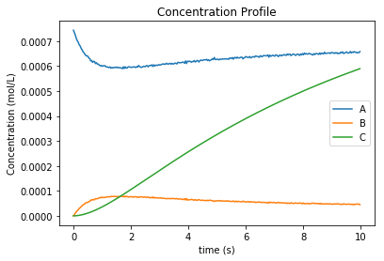

Figure 11: Concentration profile of solution to Tutorial 6

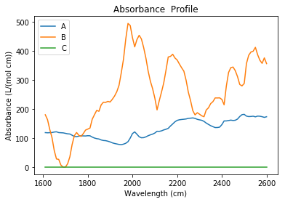

Figure 12: Absorbance profile of Tutorial 6

That concludes the basic tutorials with the types of problems and how they can be solved. Provided in Table 2 is a list of the additional examples and how they differ. While this section not only acts as a tutorial, it also shows a host of the most commonly used functions in Kipet and how they work and which arguments they take. In the next section additional functions that are included in Kipet are explained, as well as any information regarding the functions discussed in the tutorials is also included.

TABLE 2: List of example problems
Filename | Example problem description
Ex_1_ode_sim.py | Tutorial example of simulation (of reaction system 1, RS1)
Ex_2_estimation.py | Tutorial example of parameter estimation with variance estimation (of RS1)
Ex_2_estimation_conf.py | Tutorial example of parameter estimation problem above with variance estimation and confidence intervals (RS1)
Ex_3_complementary.py | Tutorial simulation that includes additional complementary states (RS2)
Ex_4_sim_aspirin.py | Tutorial simulation of an aspirin batch reactor (RS3) that shows how additional states and algebraics are used
Ex_5_sim_fe_by_fe.py | Tutorial simulation of a large reaction system (RS4) including demonstration of the finite element by finite element initialization method.
Ex_6_non_absorbing | Example of a problem where non-absorbing components are included.
Ad_1_estimation.py | Additional parameter estimation problem with known variances, but with a least squares optimization run to get initialization for the parameter estimation problem (Section 5.6). (RS1)
Ad_2_ode_sim.py | Simulation of RS3 from Sawall, et al. (2012), nonlinear system
Ad_2_scaled_estimation.py | RS3 parameter estimator, including least squares initialization, variance estimator, and parameter estimation
Ad_3_sdae_sim_non_abs.py | RS1 system with generated absorbance data and a non-absorbing component, this problem generates absorbance data and then runs a simulation that generates a D-matrix for the parameter estimation and variance estimation
Ad_4_sdae_sim.py | Tutorial problem with inputted absorbances (RS1)
Ad_5_complementary_sim.py | RS3 with temperature included in simulation
5. Additional Functionalities
Along with the functions explained in the examples, Kipet also provides users with a host of other functions that can be used. In this section some of the additional functions provided in Kipet are shown and detailed, along with some the other subtleties that may be useful to the user in implementing and improving their models.

5.1 Data manipulation tools

Kipet provides a variety of data manipulation tools and the way in which data is inputted is extremely important in order to correctly pass the results of the user’s experiments onto Kipet. This section provides a further clarification on the types of files that Kipet is able to utilize, how the data should be arranged, as well as how to use Kipet to generate data.

5.1.1 Input matrices
Loading data (D) matrices
When using Kipet for parameter estimation it is important that the data matrix, D, be inputted correctly. Kipet can read both text files (.txt) or Comma Separated Value files (.csv) from software such as Microsoft Excel or OpenOffice. Examples of data sets and how best to format them are included in the folder “Examples/data_sets”. Text files are best formulated with unlabeled columns with column 1 being time, column 2 being the wavelength, and column 3 being the absorbance associated with the specific wavelength. The method read_absorption_data_from_txt(filename.txt) automatically sorts the data and compiles it into a Pandas DataFrame for further manipulation by Kipet. Even though the order of the data is not important (except that rows need to be consistent), it is important to input the data as floating values and to separate the columns with a space.
When inputting a CSV file, it is necessary to label the columns with headings of the wavelength values and with row labels for the measuring times. The matrix will then be in the correct form with the absorption values being the entries. The read_absorption_data_from_csv(filename.csv) function is the function to call in this case.
Loading pure component absorbance data (S)
It is also possible to input S matrices. These can also be inputted in the form of CSV or txt files. In the example provided, “Ad_4_sdae_sim.py” a model is simulated given pure component absorption data. For CSVs the components label the columns and the wavelengths label the rows. The relevant absorption values fill the matrix. For text files the rows can be unordered, but must be column 1: wavelength, column 2: component name, column 3: absorption. To input this into Kipet we use a similar format as previously described:
S_frame = read_absorption_data_from_txt(filename)

After this is formatted into the Pandas DataFrame using the above code, we will need to add the data to our model using:
builder.add_absorption_data(S_frame)

If we plan to use this data to simulate a specific system and perhaps generate a data file (spectra) we will also need to add measurement times to our new model. In the example this is chosen as:
builder.add_measurement_times([i*0.0333 for i in range(300)])

5.1.2 Generating input matrices

It is also possible to generate matrices using some of the built-in functions in Kipet. One such function is able to generate pure-component absorbance data based on Lorentzian parameters:

S_frame = generate_absorbance_data(wl_span,S_parameters)

Where wl_span is the wavelength span that you wish to generate the data for in the form of a vector where the first entry is the starting wavelength, second is the ending wavelength and the third is the step-length. S_parameters is a dictionary of parameters for the Lorentzian distribution function, ‘alphas’, ‘betas’, and ‘gammas’. This function will generate an absorbance profile DataFrame.
It is also possible to generate a random absorbance data with the function:
generate_random_absorbance_data(wl_span,component_peaks, component_widths = None, seed=None)

Where the wl_span is the same as above, component_peaks is the maximum height of the absorbance peak, component_widths is the maximum Lorentzian parameter for gamma, and seed is the possible seed for the random number generator.
5.1.3 Writing matrices to files
Kipet also provides functions to write generated matrices to a file with the following functions:
write_absorption_data_to_csv(filename,dataframe)
write_absorption_data_to_txt(filename,dataframe)

Where the user can define the filename and which DataFrame to input.
It is also possible that a user might wish to generate a spectral D-matrix from a file and then write this to a file. This can be done using:
write_spectral_data_to_txt(filename,dataframe) write_spectral_data_to_csv(filename,dataframe)

Which takes in the same inputs as the other function, filename in the form of a string to be used as the output file name and dataframe which is the pandas DataFrame that is to be written.
5.1.4 Plot spectral data
It is possible to directly plot spectral data using:
plot_spectral_data(dataFrame,dimension='2D')
Where the inputs dataFrame is the spectral data matrix that you wish to plot and the dimension is the dimension of the graph. For the D-matrix, it is more appropriate to change the dimension to ‘3D’ in order to plot the spectra with time as well as wavelength and absorbance.
5.2 Pyomo Simulator
While tutorial 1 already explained how to use the simulator class, for completion this section provides the full array of options available to the user for the run_sim function:

run_sim(solver,**kwds):
""" Runs simulation by solving a nonlinear system with ipopt

Arguments:
solver (str, required): name of the nonlinear solver to used

solver_opts (dict, optional): Options passed to the nonlinear solver.

variances (dict, optional): Map of component name to noise variance. The map also contains the device noise variance.

tee (bool,optional): flag to tell the simulator whether to stream output to the terminal or not

Returns:
None

5.3 Optimizer Class
Since tutorial 2 already explains how to make use of the functions in this section, for completion the user is provided with the full array of options available to the user for the run_lsq_given_P function which can be used to initialize any of the optimization functions to obtain parameters or variances:

run_lsq_given_P(self,solver,parameters,**kwds):
"""Gives a raw estimate of S given kinetic parameters based on a difference of least-squares analysis

Arguments:
solver (str, required): name of the nonlinear solver to used

solver_opts (dict, optional): options passed to the nonlinear solver

variances (dict, optional): map of component name to noise variance. The map also contains the device noise variance

tee (bool,optional): flag to tell the optimizer whether to stream output to the terminal or not

initialization (bool, optional): flag indicating whether result should be loaded to the pyomo model or not

Returns: Results object with loaded results
"""

5.4 VarianceEstimator
Since tutorial 2 already explains how to make use of the functions in this section, for completion the user is provided with the full array of options available to the user for the run_opt function for the VarianceEstimator class:

def run_opt(self, solver, **kwds):

"""Solves variance estimation problem following the procedure shown in Figure 4 of the documentation. This method solved a sequence of optimization problems to determine variances and also automatically sets initialization for the parameter estimation for the variables.

Args:
solver_opts (dict, optional): options passed to the nonlinear solver

tee (bool,optional): flag to tell the optimizer whether to stream output to the terminal or not.

norm (optional): norm for checking convergence. The default value is the infinity norm (np.inf), it uses same options as scipy.linalg.norm

max_iter (int,optional): maximum number of iterations for the iterative procedure. Default 400.

tolerance (float,optional): Tolerance for termination by the change Z. Default 5.0e-5

subset_lambdas (array_like,optional): Subset of wavelengths to used for the initialization problem, as described in Chen, et al. (2016). Default all wavelengths.

lsq_ipopt (bool,optional): Determines whether to use ipopt for solving the least squares problems in the Chen, et al. (2016) procedure. Default False. The default uses scipy.least_squares.

init_C (DataFrame,optional): Dataframe with concentration data used to start the iterative procedure.

Returns: None

"""

5.5 Parameter Estimator
Since tutorial 2 already explains how to make use of the function in this section, for completion the user is provided with the full array of options available to the user for the run_opt function for the ParameterEstimator class:

def run_opt(self, solver, **kwds):
""" Solves parameter estimation problem.
Arguments:
solver (str): name of the nonlinear solver to used

solver_opts (dict, optional): options passed to the nonlinear solver

variances (dict, optional): map of component name to noise variance. The map also contains the device noise variance.
tee (bool,optional): flag to tell the optimizer whether to stream output to the terminal or not.

with_d_vars (bool,optional): flag to the optimizer whether to add
variables and constraints for D_bar(i,j), which is included when we have a problem with noise

covariance(bool, optional): if this is selected, the confidence intervals will be calculated for the estimated parameters. If this is selected then the solver to be used should be ‘ipopt_sens’ or else an error will be encountered.

Returns: Results object with loaded results

"""

5.6 Troubleshooting and advanced strategies for difficult problems
Since the problems that Kipet is solving are often highly non-linear and non-convex NLPs, it is often important to provide the solver (IPOPT) with good initial points. This section will briefly describe some of the additional initialization and solver strategies that can be applied in Kipet in order to solve larger and more difficult problems. This section assumes that the user has read the tutorial problems above.
Since the VarianceEstimator needs to solve the full optimization problem, it may be useful to initialize it. It is possible to do this by fixing the unknown parameters to some value (hopefully fairly close to the real values) and then running a least squares optimization in order to get decent initial values for the variables, Z, S, dZ/dt, and C. eg.. Kipet provides the ability to do this through an easy to implement function:
p_guess = {'k1':4.0,'k2':2.0}
raw_results = v_estimator.run_lsq_given_P('ipopt',p_guess,tee=False)

v_estimator.initialize_from_trajectory('Z',raw_results.Z)
v_estimator.initialize_from_trajectory('S',raw_results.S)
v_estimator.initialize_from_trajectory('dZdt',raw_results.dZdt)
v_estimator.initialize_from_trajectory('C',raw_results.C)

This will allow the user to initialize the VarianceEstimator using the same methods and functions described in the tutorial sections. Note that it is possible to use the run_lsq_given_P() to initialize the ParameterEstimator method as well if the variances are known or there is no need to compute variances. An example of this is shown in Ad_1_estimation.py.
When running the ParameterEstimator it is possible to improve solution times or to assist IPOPT in converging to a solution by not only providing initializations (either through a least squares with fixed parameters or using the results from the VarianceEstimator) as shown above but also by scaling the NLP. Kipet provides a tool to provide automatic scaling based on the VarianceEstimator’s solution with the following function.

p_estimator.scale_variables_from_trajectory('Z',results_variances.Z)
p_estimator.scale_variables_from_trajectory('S',results_variances.S)
p_estimator.scale_variables_from_trajectory('C',results_variances.C)

and this can then be given to the solver as an option in the following way:

options = dict()
options['nlp_scaling_method'] = 'user-scaling'
results_pyomo = p_estimator.run_opt('ipopt', tee=True, solver_opts = options,variances=sigmas, with_d_vars=True)

If convergences are extremely slow it is also possible to provide the solver with an additional option that changes the barrier update strategy. This option may not necessarily be required, but can help with some problems, especially with noisy data. This is added to the solver options with this:
solver_options['mu_strategy'] = 'adaptive'

Another useful solver option that has not yet been mentioned in this guide and which might help to improve the chances of obtaining a solution is the:
options['bound_push'] =1e-6
Which is the desired minimum distance from the initial point to bound. By keeping this value small it is possible to determine how much the initial point might have to be modified in order to be sufficiently within the bounds.
More information on the IPOPT solver and the available options can be found here:
https://www.coin-or.org/Ipopt/documentation/node2.html

6. REFERENCES

Hart, W.E., Laird, C., Watson, J.P., Woodruff, D.L., 2012, Pyomo: Optimization Modeling in Python, volume 67, Springer Verlag.

HSL, 2013, A collection of Fortran codes for large scale scientific computation. http://www.hsl.rl.ac.uk

Hunter, J.D., 2007, Matplotlib: A 2D Graphics Environment, Computing in Science & Engineering, 9, 90-95, DOI:10.1109/MCSE.2007.55

McKinney W., 2013, Python for Data Analysis: Data Wrangling with Pandas, NumPy, and Ipython

van der Walt, S., Colbert, C., Varoquaux, G., 2011, The NumPy Array: A Structure for Efficient Numerical Computation, Computing in Science & Engineering, 13, 22-30, DOI:10.1109/MCSE.2011.37

Wächter, A., Biegler, L.T., 2006, On the Implementation of an Interior-Point Filter Line-Search Algorithm for Large-Scale Nonlinear Programming, Mathematical Programming, 106(1): 25-57.

Sawall, M., Boerner, A., Kubis, C., Selent, D., Ludwig, R., Neymeyr, K., 2012, Model-free multivariate curve resolution combined with model-based kinetics: algorithm and applications. J. Chemometrics, 26: 538–548.

Chen, W., Biegler, L.T., Garcia-Munoz, S., 2016, An Approach for Simultaneous Estimation of Reaction Kinetics and Curve Resolution from Process and Spectral Data, Journal of Chemometrics, 30, 506-522.

Puxty, G., Maeder, M., Hungerbuhler, K., 2006, Tutorial on the fitting of kinetics models to multivariate spectroscopic measurements with non-linear least-squares regression. Chemometrics and Intelligent Laboratory Systems, 81, 149–164.

Jaumot, J., Gargalloa, R., de Juana, A., Tauler, R., 2005, A graphical user-friendly interface for MCR-ALS: a new tool for multivariate curve resolution in MATLAB. Chemometrics and Intelligent Laboratory Systems, 76, 101–110

Fogler, H. S., 2006, Elements of Chemical Reaction Engineering (4th Edition), Prentice Hall International.

